2011 Box Elder Sheriff’s Office Annual Report

2-Sheriff’s Message
4-County Demographics
4-Organizational Chart
5-Mission Statement
7-Department Patch
8-Uniforms/Vehicles
9-Budget
10-Detectives

Strike Force

# of cases, arrests, quantity of drugs seized
12-Civil

Number of services (10 years)
13-Court
14-Patrol

CAR, K-9, DARE, SWAT, DRE

# of Calls For Service

Citations and Warnings

Speed-Box
21-Corrections

Personnel assignments

Inmate worker programs

# of bookings, inmate count
24-ITS
24-Communications
24-Emergency Management
24-Building and Grounds
25-Fire Marshall
26-Volunteers

Search and Rescue

Scuba

Horse Posse

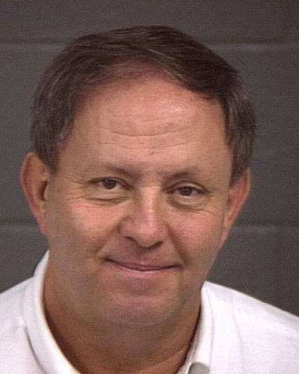

Message from Sheriff Yeates

Welcome. After 33 years working for the Sheriff’s Office, I was elected and took office in January 2007. In November 2010, I was re-elected for another four year term. I appreciate the opportunity the citizens have given me to serve them and it has been a pleasure to do so. The purpose of this annual report is to explain to the citizens what changes have been made during the last year, provide crime statistics and explain the efforts on our part to serve the public.

My focus has been to create new or enhance existing partnerships with the citizens. Preparing this annual report is just one way of bettering the communication between the public and my office. I hope the information presented here answers questions and gives insight into our operations. After taking office, I informed my employees that nothing would be as important during my tenure as Sheriff as community relations. I truly believe this and continually reinforce this principle. For example, I instituted a program in which citizens that had contact with a deputy are surveyed on a random basis and asked about their encounter. This lets the citizens know I am truly concerned about their interaction with the department and lets the deputies know I am holding them accountable.

All of the department functions are explained in this report. As you will see, our department provides a variety of services. About half of our budget goes to corrections and a fourth to patrol. The majority of the budgets are spent on personnel.

The size and terrain of Box Elder County makes it a particularly unique and wonderful place to live. These same attributes, plus a growing population, create challenges for the Sheriff’s Office. It will take great efforts by the Sheriff’s Office to keep pace with the changing nature of our county. It will be impossible to accomplish without a cooperative effort with our citizens.

Box Elder County Population 2011 | 49,902
BESO Area of Assigned Responsibility | 14,985
*BESO Sworn Officers | 28
*Administration, Patrol, Investigations
# of Officers per 1000 population | 1.87

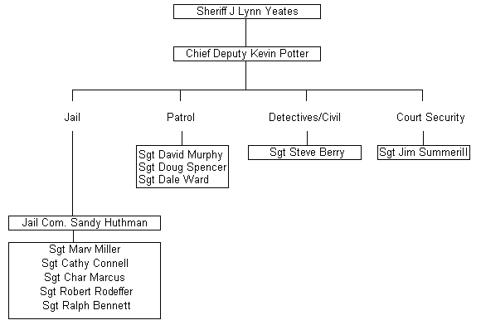

Direction and Guidelines for Sworn Officers

Sheriff J. L. Yeates - January 2011

Mission Statement
-Reduce crime and the fear of crime.
-Establish a solid partnership with the citizenry to create safe and secure communities.
-Provide a knowledgeable staff that ensures professional commitment to law enforcement, is focused and dedicated to the citizens and communities and uses imagination, innovation and resourcefulness.
-Provide high quality, cost effective, accountable services.
-Standards for law enforcement must include Fair Access, Public Trust, Safety and Security,
-Coordinated Team Work with officers and citizens and Community Involvement/Responsibility.

Nothing will be as important in my tenure as Sheriff as community relations. Most of the citizens of this county may have only one contact with an officer in their life. Their perception of our department and me personally comes from that contact. Contact with law enforcement is, for most people, a highly unusual event and is remembered for a long time. I expect every citizen who has contact with an officer to leave with the feeling they were dealt with by a competent, knowledgeable, well-trained professional who was polite and courteous. In addition, a citizen making a complaint should feel the officer did everything they could to solve the case or find a resolution. Most important is to follow up, even if that means nothing has developed in their case. If they need a question answered and you don't know, find out and call them back. If you refer them to another agency or department, give them a phone number and a contact name.

Law enforcement is a profession. Professions require schooling to achieve certification, continuing education requirements, specializations, decertification, etc. By definition, you are a professional. Take pride in your dress and appearance. Please represent yourself like a professional to the public and others in your profession.

Professionals train constantly. The 40 hours a year required by POST barely covers keeping your various certifications current. Find and request training in your weak areas. Become an expert or instructor in your strengths. Care about what is going on in law enforcement and keep up with current trends. I will support training that gives technical expertise and instructor status with the understanding that budget and benefit to the department are considerations. Expect to come back from training and teach what you learned to the department.

A law enforcement officer's authority and power to take away a citizen’s constitutional rights is unmatched anywhere in our society. Never, ever abuse this privilege or the position of trust you hold. Your word is your bond and should be in all your dealings.

In return, you can expect from me that I will support training, programs, equipment and a pay scale which represent professional policing. I understand that no one knows how to do a job better than the one doing it. I want your input and feedback, through your supervisor, on what’s being done right and what needs improvement.

I will follow the chain of command and expect you to do the same.

Department Patch

Green and Tan colors- represent Sheriff’s Colors and mountain and desert surroundings.
1856- Year the Box Elder Sheriff’s Department was established.
Trains/Spike- Transcontinental railroad completed in our county

Marshland- Migratory Bird Refuge
Mountains- Represent the various mountain ranges in our county, some of which are almost 10,000 ft.
History, Agriculture and Industry- Three things that make Box Elder County famous and a great place to live in.

Uniforms
While the department colors haven’t changed, new hats, jackets, pants and other items have been approved.

Vehicles
We have a fleet managment program whereby all deputies will have 4 wheel drive vehicles. The size and terrain of our County require 4 wheel drive in many cases. In the past, deputies would have to switch vehicles to respond to calls in certain areas. We felt valuable time was wasted during this switch.

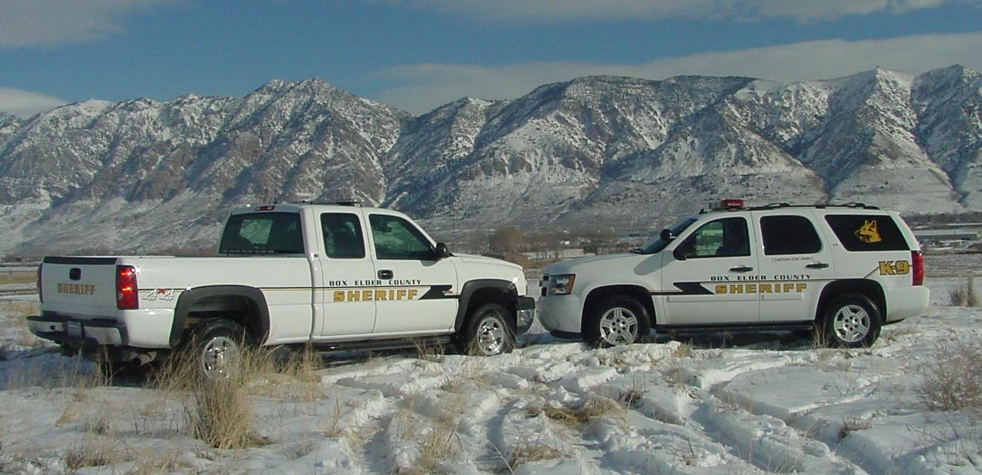

Budget
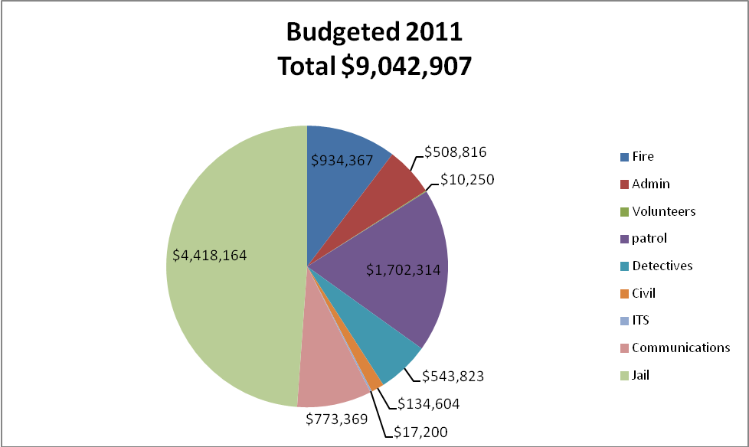
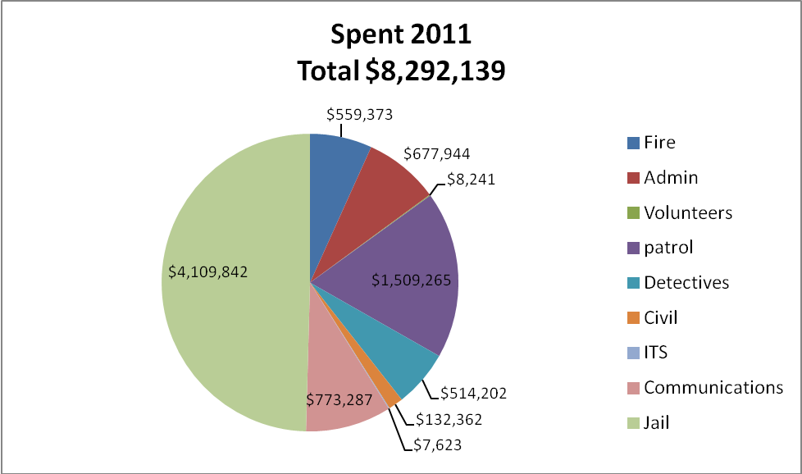

Detective Division 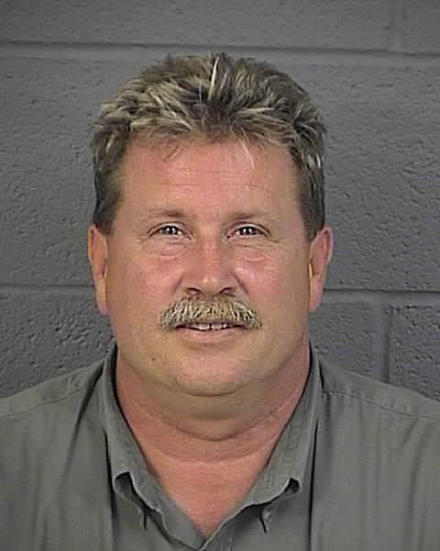
The detectives are supervised by Sgt. Steve Berry. Sgt Berry is also the field supervisor for the Narcotic Task Force and Civil division.

The detective division investigates major crimes committed in the county. There are four detectives, one of whom is assigned full time to the multi-jurisdictional narcotic task force. The other three detectives specialize in property crimes, sex crimes, fraud, death investigation, internal investigations, and crime scenes. They also manage the evidence room.



Box Elder County Multi-Jurisdictional Narcotic Task Force (Strike Force)

The Sheriff’s Department participates in the Strike Force by assigning one full-time detective and a part-time field supervisor. Brigham Police also provide a full-time detective and part-time administrator. Tremonton Police provides a full-time detective. Most other jurisdictions provide some part-time help.
The Strike Force was set up to allow targeted, focused investigation on drug use and traffic in Box Elder County. The Strike Force operates with the assistance of federal grants. The Strike Force also gives presentations to work, social, school, and civic groups. If you would like a presentation, please call the Strike Force secretary at (435)734-3813

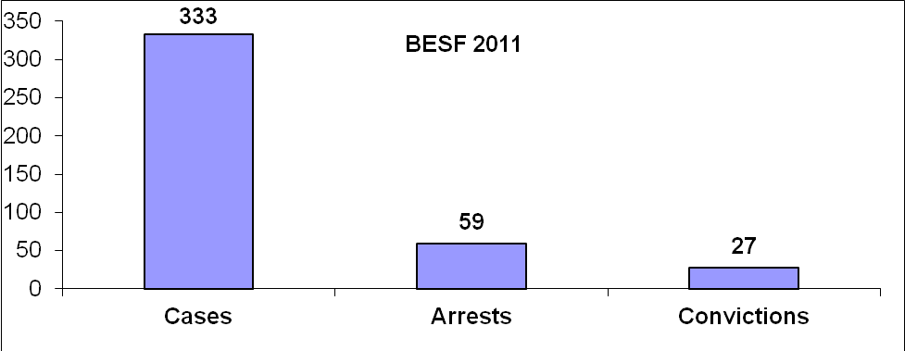

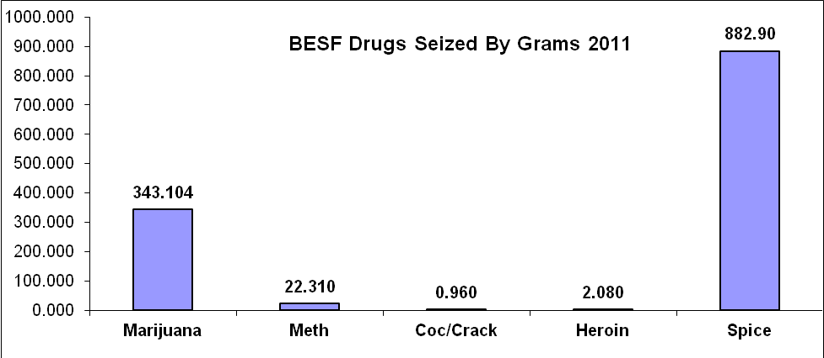
*Also seized were 138 Rx Pills Valued at about $2760.

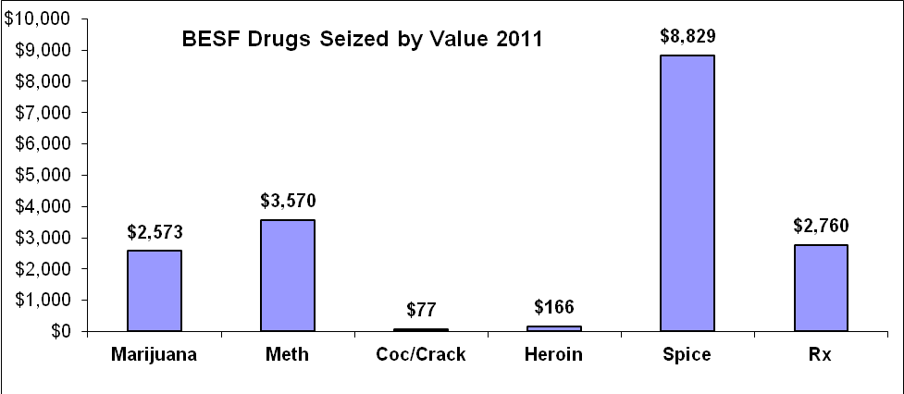

Civil Division

The Sheriff is assigned by law to serve civil processes and execute court orders. There is a full-time deputy and full-time secretary assigned to this division. Often, the Patrol or Detective Division will assist in civil process serving to meet demand.

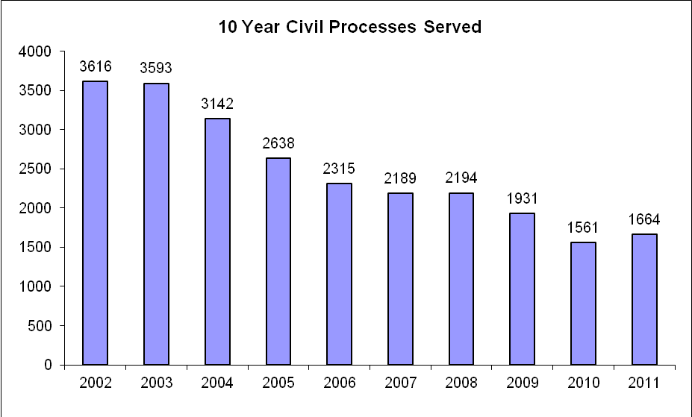

Court Division 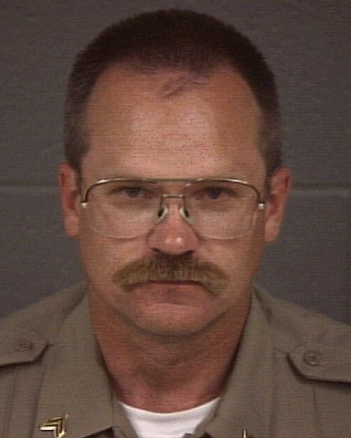

This division is supervised by Sgt. Jim Summerill.

The Sheriff is required, by law, to provide services to the District Court, Juvenile Court and the new Box Elder Justice Court building. This includes Bailiff duties and building security.

A Bailiff of the court is tasked with the safety of the judge and court staff and to maintain order in the courtroom.

The Security aspect includes monitoring court buildings and areas through a control center, magnetometers, security entry points and uniformed officers.

District Court Bailiff Hours: 1,993.25

Justice Court Bailiff Hours: 1,598.50

Total Hours 3,591.75

District Court Security Hours: 6,750

35,118 visitors to the 1st District Court House.

Patrol Division 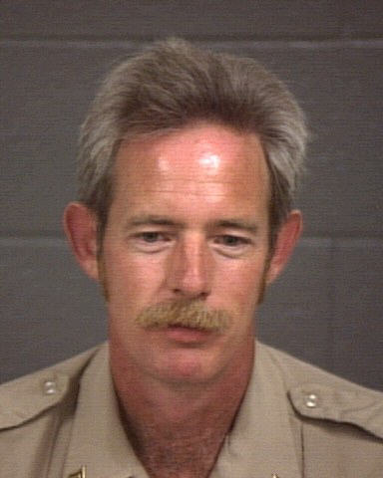 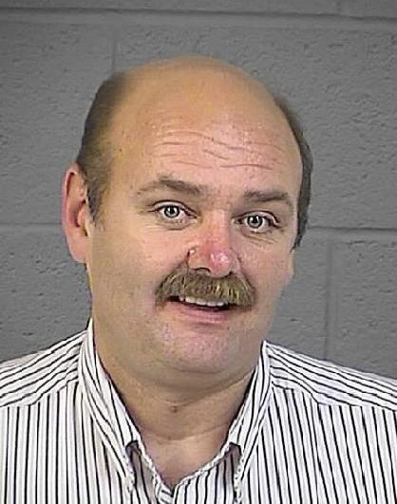 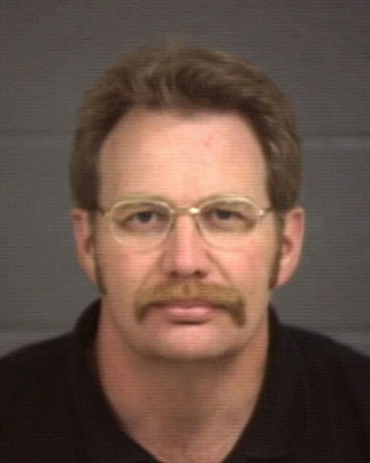
Murphy Spencer Ward

The patrol division is supervised by Sgt. Dave Murphy, Sgt. Doug Spencer, and Sgt. Dale Ward. There are 15 deputies and 3 Sergeants assigned to cover the county 24 hours a day. Due to the size of the county, deputies are assigned to cover patrol areas during their shifts. This includes the western part of the county.

Community Area Representatives –CAR
In additional to regular patrol duties, deputies are assigned a town or area in the county. They are expected to attend community meetings or functions and have an expertise in that community. To find out what deputy is assigned to your area, please call one of the patrol Sgts. (Sgt. David Murphy 435-734-3826, or Sgt. Doug Spencer 435-734-3807 or Sgt. Dale Ward 435-734-3805).

K-9
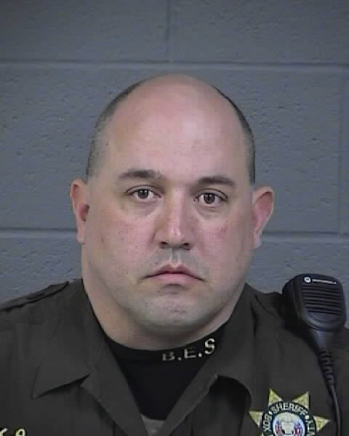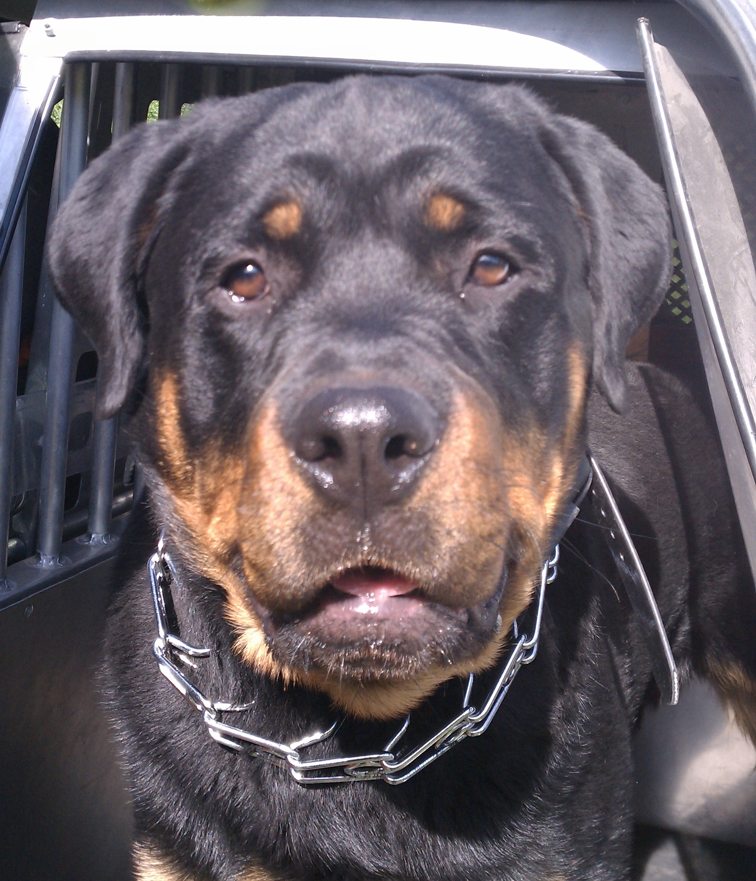
Deputy Yates is an experienced dog handler and previously served three years with K-9 Kosmo. When Kosmo died at the end of 2010, Deputy Yates started training a new Rottweiler puppy, Tonka. Tonka has matured during 2011 and is ready to fight crime.

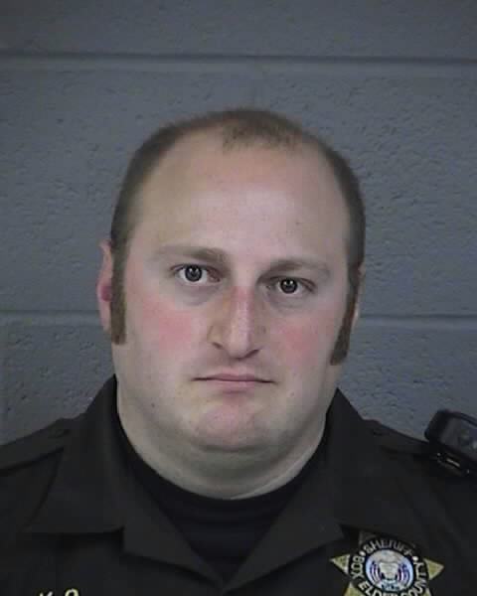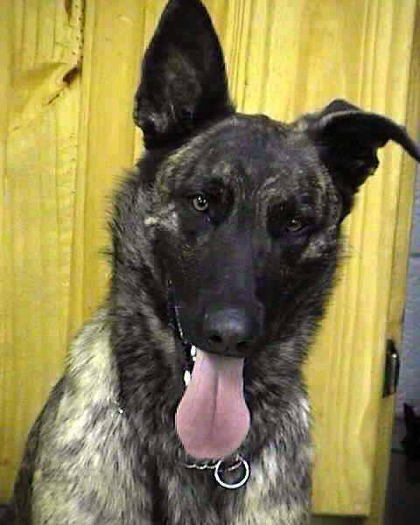
Deputy Ted Bennett was picked as a new K9 handler in 2011. He will be working with K-9 Guri, a Dutch/German Shepherd. They are scheduled to attend a 3 month K-9 training and certification at the Police Academy starting January 2012.

SWAT/SOG/Negotiations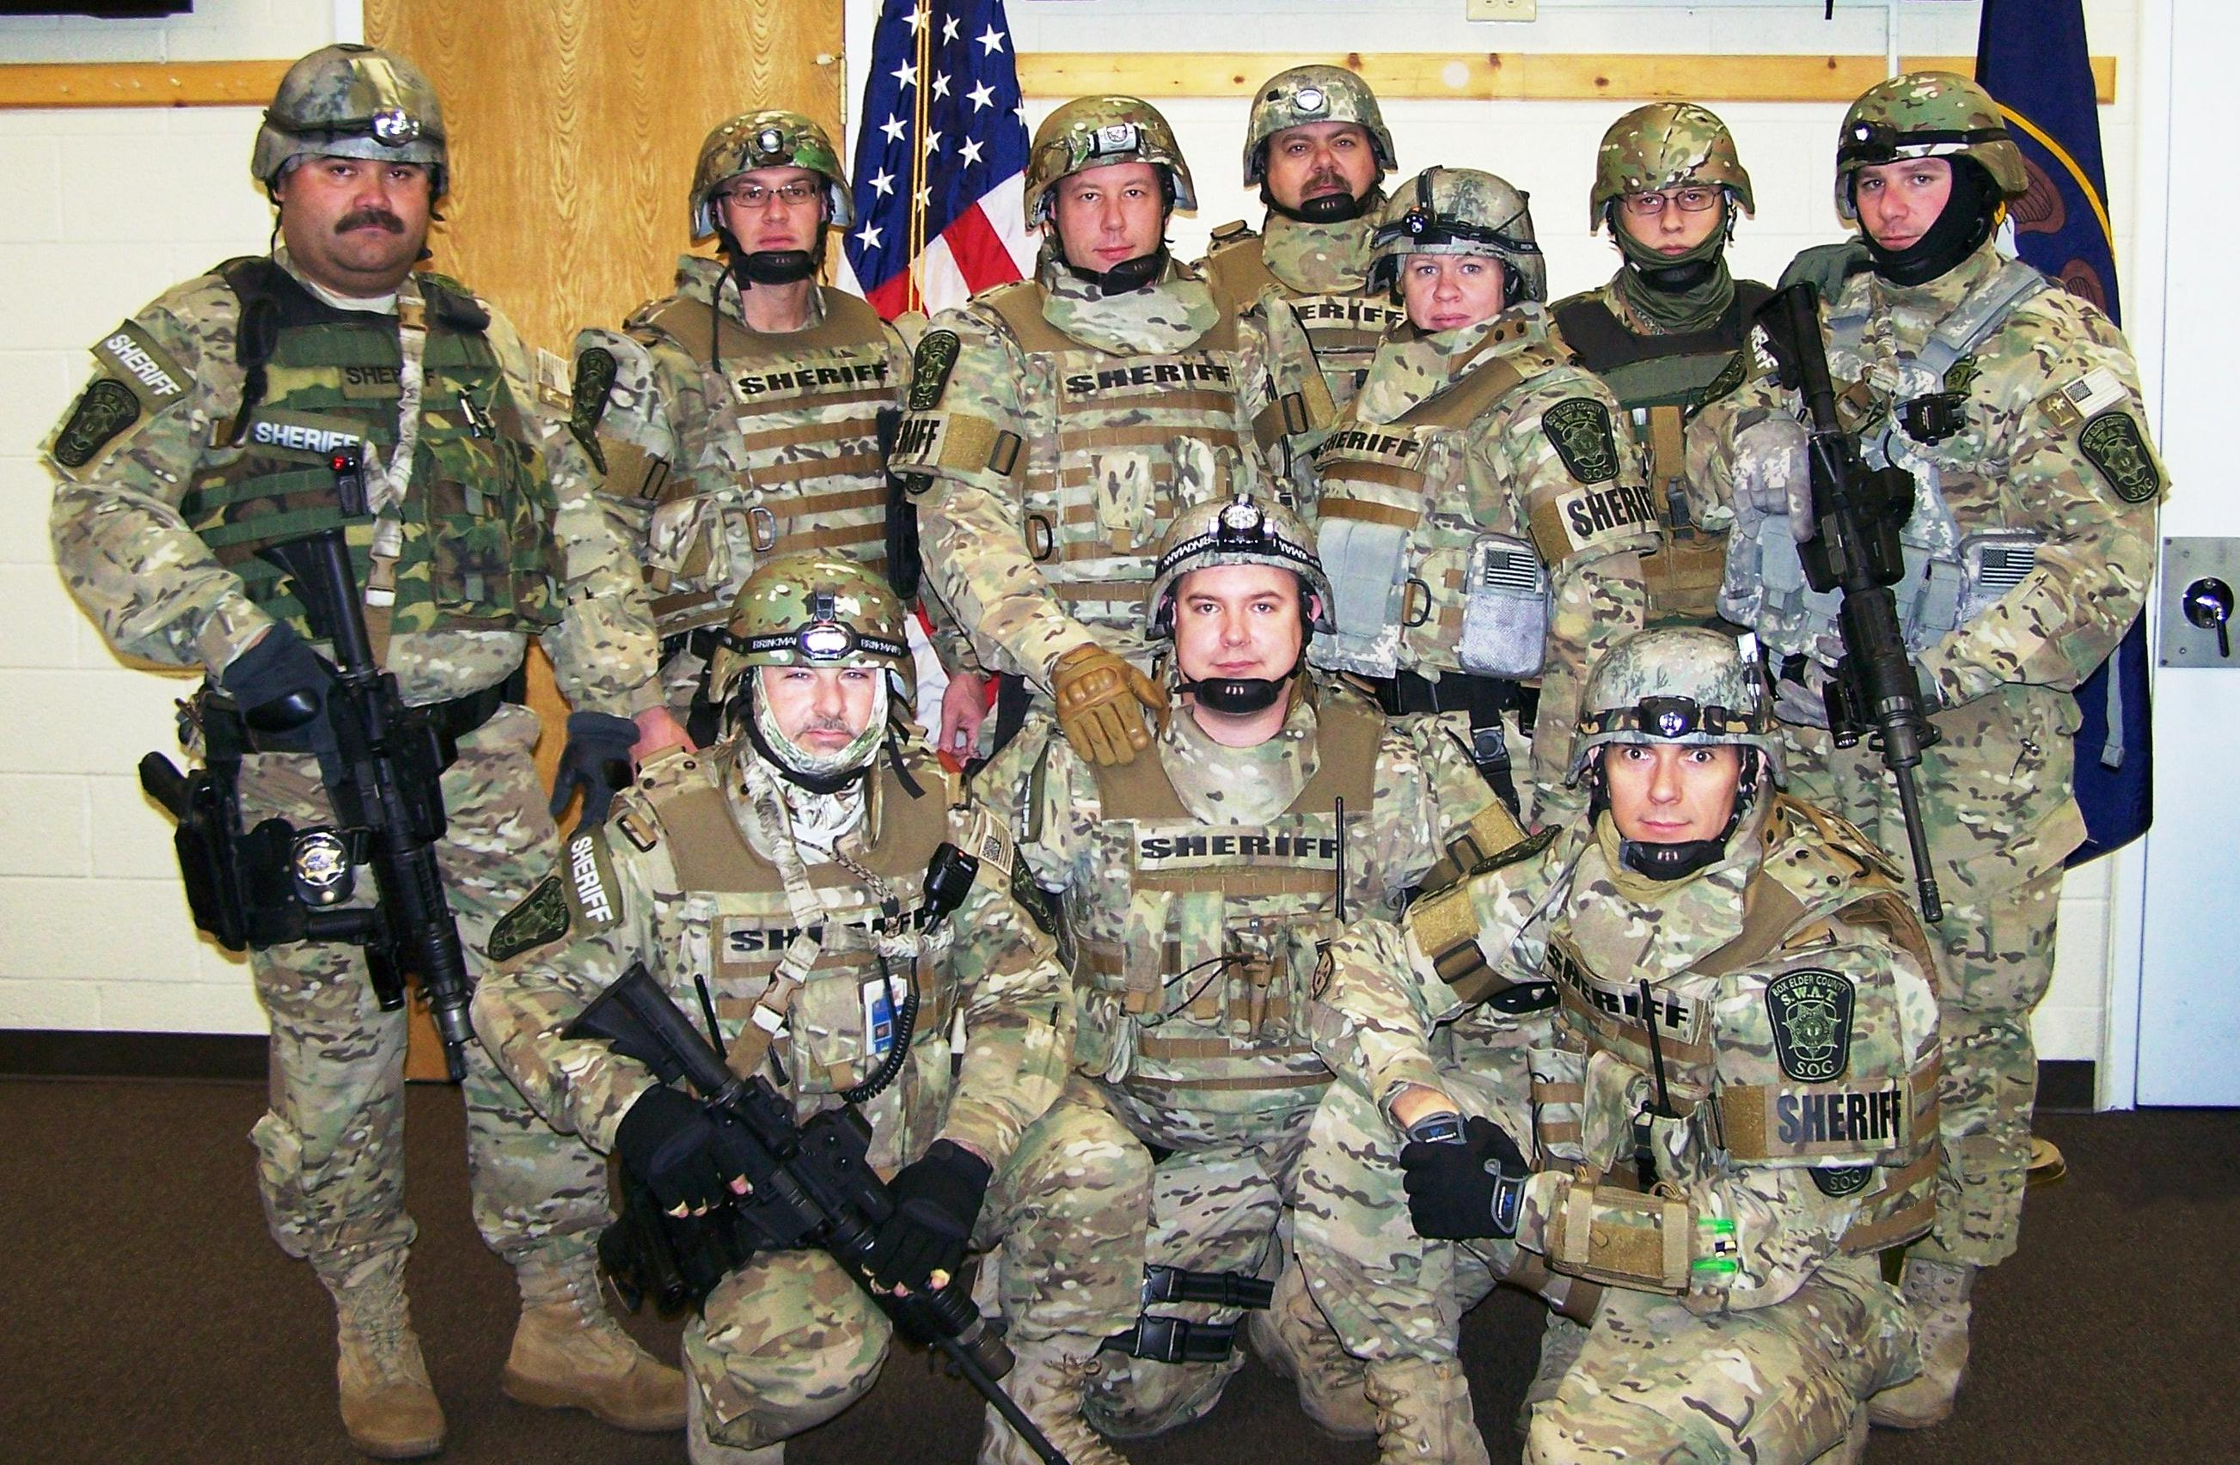
BESO started up a new county team comprised of BESO officers and will respond to SWAT/SOG calls in the areas patrolled by BESO and other areas upon request.
Our Negotiations Team is comprised of 4 officers who are certified or are currently attending a certification in negotiations.

Drug Recognition Experts (DRE)
The county has Officers certified as DRE. The Officers are trained to recognize the physical, clinical and neurological signs and symptoms associated with different kinds of drug use. DRE’s are an invaluable asset for drug related DUI’s and other crimes.

2011 Calls for Service by Nature
911 Unknown | 67 |  | Gas Skip | 16 |  | Sex Offense | 19
Abandoned Vehic | 33 |  | Harassment | 29 |  | Sheriff Service | 2
Admin Assn | 2 |  | HAZMAT | 1 |  | Simple Assault | 20
Agency Assist | 466 |  | Health & Safety | 6 |  | Slide Off | 14
Aggrav Assault | 3 |  | Hit & Run PD | 8 |  | SRT | 4
Alarm | 90 |  | Illegal Burning | 7 |  | Stab/Gunshot | 5
Alcohol Offense | 13 |  | Impound | 7 |  | Stalking | 3
Animal Issuses | 184 |  | Intoxication | 4 |  | Suicide | 1
Attempt Locate | 3 |  | Juvenile Prob | 54 |  | Suicide Attempt | 4
Bad Check | 4 |  | K9 | 4 |  | Suicide Threat | 14
Burglary | 50 |  | Keep The Peace | 1 |  | Susp Person | 40
Business Licens | 2 |  | Littering | 3 |  | Suspicious | 131
Carbon Monoxide | 1 |  | Livestock | 78 |  | Suspicious Vehi | 79
Child Abuse | 18 |  | Lost Property | 10 |  | Tel Harassment | 10
Citizen Assist | 333 |  | Mail Offenses | 1 |  | Theft | 130
Citizen Dispute | 38 |  | Media Relations | 1 |  | Theft Automobil | 6
Civil Problem | 36 |  | Medical | 12 |  | Theft Motorcycl | 1
CO Poisoning | 2 |  | Medical Assist | 111 |  | Theft Vehicle | 3
Com Policing | 12 |  | Mental Problem | 2 |  | Threatening | 30
Curfew | 1 |  | Missing Juvenil | 6 |  | Tip | 18
Custodial INT | 19 |  | Missing Person | 6 |  | Tobacco Problem | 2
Death Invest | 10 |  | Motorist Assist | 27 |  | Traffic Enf | 11
Disorderly | 9 |  | Noise Complaint | 24 |  | Traffic Hazard | 70
Drug Rec Expt | 22 |  | Overdose | 8 |  | Traffic Offense | 38
Drugs | 21 |  | Paper Process | 3 |  | Traffic Problem | 3
DUI | 19 |  | Parking Problem | 8 |  | Traffic Stop | 24
Elderly Abuse | 1 |  | PD Accident | 73 |  | Transport Pris | 2
Escape Custody | 1 |  | PI Accident | 28 |  | Traumatic Injur | 1
Extra Patrol | 181 |  | Pornography | 2 |  | Trespassing | 46
Failure Appear | 1 |  | Property Damage | 34 |  | Trouble Ticket | 1
Fall | 1 |  | Prot Order Viol | 7 |  | Unknown Trouble | 2
Family Fight | 49 |  | Prowler | 4 |  | Unsecure Premis | 73
Fatal Accident | 1 |  | Psychiatric | 3 |  | Utility Problem | 3
Fire | 6 |  | Public Relation | 1 |  | Vagrancy | 3
Fire Assist | 59 |  | Reckless Drivin | 13 |  | Vandalism | 36
Fire Grass | 1 |  | Recovered Veh | 4 |  | Vehicle Burg | 34
Fireworks | 3 |  | Road Closure | 1 |  | Vehicle Fire | 2
Fix It Ticket | 7 |  | Road Debris | 3 |  | Vehicle Lockout | 2
Follow Up Inv | 6 |  | Road Rage | 1 |  | Vehicle Search | 1
Forgery | 1 |  | Runaway Juvenil | 12 |  | VIN Inspection | 217
Found Child | 2 |  | Safety Hazard | 5 |  | Wanted Person | 105
Found Property | 19 |  | Search & Rescue | 2 |  | Weapon Offense | 31
Fraud | 48 |  | Search Warrant | 1 |  | Welfare Check | 62
Gas Leak | 1 |  | Security Check | 58 |  | Wildlife | 6

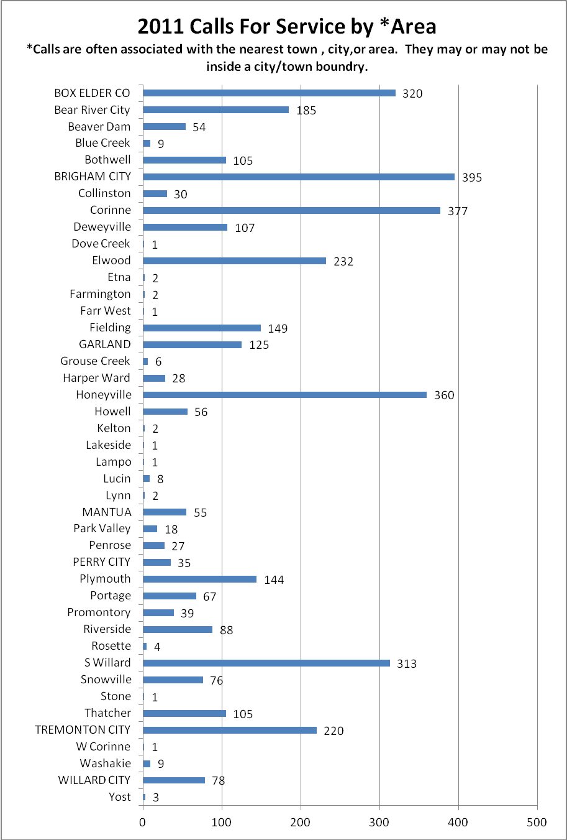
Total 3841

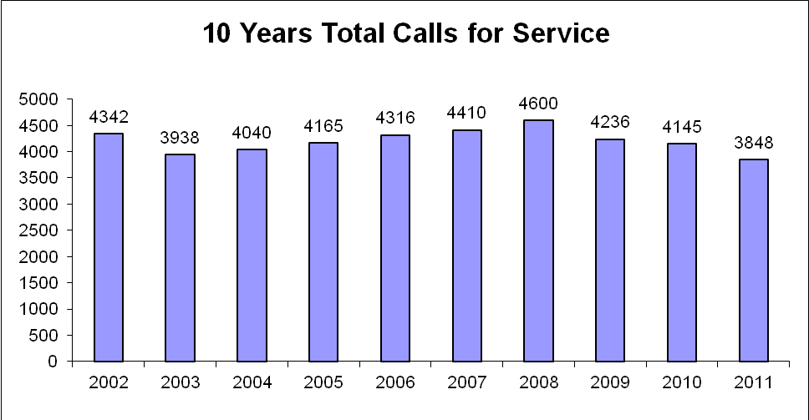

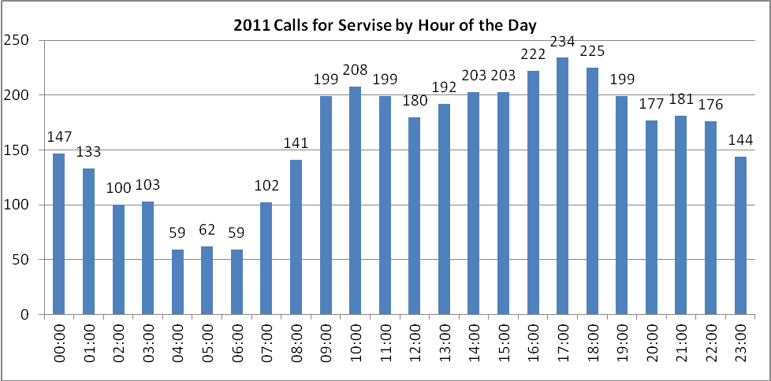

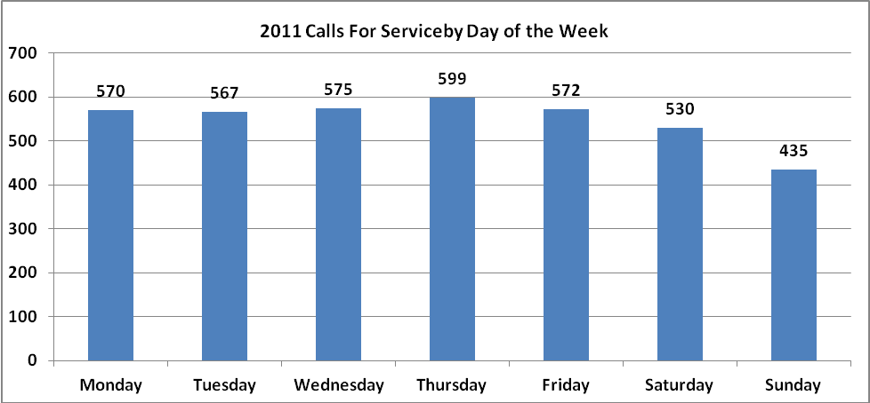

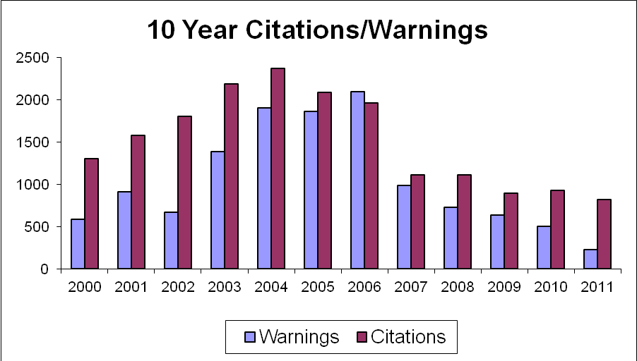
*227 Verbal warnings for traffic violations were also given in 2011.

Speed-Box

At the end of 2009 the Department purchased a device that measures traffic at specific locations. The Speed-Box, as we like to call it, can be placed at any location in the County to measure 4 traffic statistics; how many vehicles passed by, time of day, speed, and direction of travel. From this data we see the true picture of each location’s traffic. This data helps Deputies know how best to conduct speed enforcement.

Corrections Division 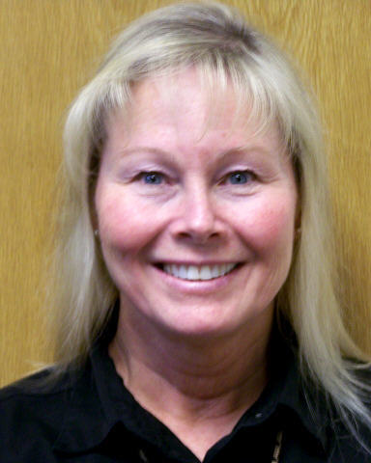

The Corrections division is supervised by Commander Sandy Huthman.

The Sheriff is required by law to maintain a county jail. Our facility has 168 inmate beds with twenty six of those beds reserved for females. We also house inmates for the State Prison under contract. There is a mix of Dormitory and Pod style with individual cell type housing. It requires a variety of assignments to maintain a correctional facility including:

Floor and control room officers
These officers ensure the security of the inmates and monitor the day to day activity.

Inmate services
These officers are responsible for commissary, billing and accounts.

Kitchen
Civilian cooks along with inmate workers provide three meals a day.

Transport
These officers escort inmates to court appearances, medical appts., etc.

Medical
The jail contracts with a local doctor for medical services. The doctor visits inmates twice a week. There is one full-time and one part-time nurse to see routine medical issues.

Work Crew
Officers take inmate workers to various areas in the county for labor. Inmate crews have worked at the Landfill, courthouse, fairgrounds, food bank and for different municipalities. Inmate workers also staff the laundry, kitchen, warehouse and cleaning crews.
Pay For Stay
Pursuant to Utah code 76-3-201(6) (May 29, 2009) The county jail is now charging inmates $10 a day for their incarceration.
Day Reporting (Non-Felony)
In January of 2009 we began using the Day Reporting (non- felony) program. This program is another option the Judge can use in lieu of jail time. In this program a person convicted of a crime could be sentenced to a number of days of Day Reporting. The convicted would report to the Day Reporting Officer and be subject to drug testing. The convicted would also pay $30 a month as well as the costs for the drug testing.
Work Release
Some inmates are allowed to work their normal jobs and return to jail at night.

Programs

Inmates may take classes in the following areas:
Substance abuse, including Alcoholics Anonymous, Narcotics Anonymous, Power over Addiction and 12 step meetings.

Anger Management

GED

Parenting

Religious services

High School Diploma

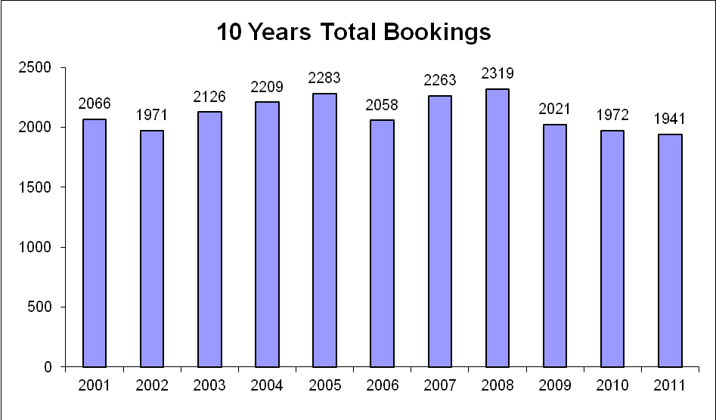

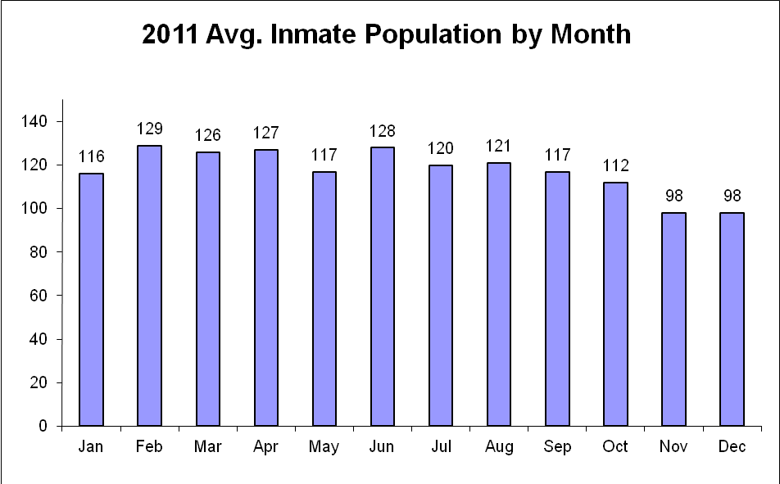

ITS 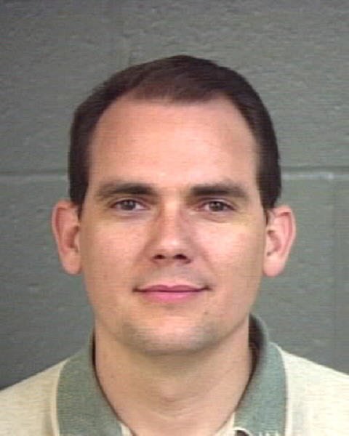
Corrections Officer Russell Roberts is responsible for the maintenance, repair, upgrades and replacement of computers, laptops and servers at the Sheriff’s Office.

Communications/Dispatch

Box Elder Communications Center (BECC) is managed by the State of Utah thru Lesa Wilson, manager.

Emergency Management
Emergency Management is the process of mitigating, planning, responding and recovering from natural disasters/terrorism/haz-mat. The Chief Deputy and the Sheriff have this assignment.
Emergency Medical Services falls under the Sheriff who oversees 12 Emergency Medical technicians and ambulances in Park Valley and Grouse Creek.

Buildings and Grounds
A full-time civilian employee is responsible for the care, repair, maintenance and upkeep at the jail, offices, West cabins and storage buildings.

Fire Marshall 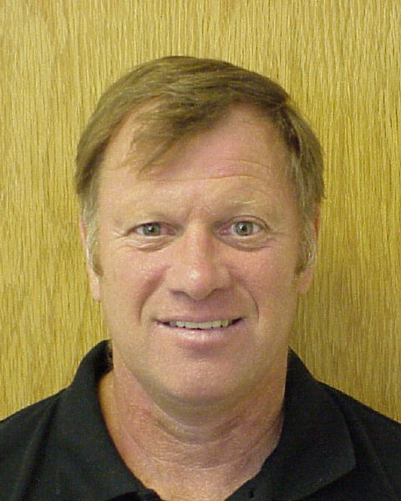

Greg Martz is the Box Elder County Fire Marshall.

Wildland fires in the un-incorporated areas of the county are a Sheriff’s responsibility by law. That’s why the Fire Marshall works out of the Sheriff’s Office. There is one full-time Fire Marshall and one part-time secretary. Part-time marshals are hired during fire season. Contracts with local fire departments give the county the manpower needed to fight Wildland fires. There is state and federal reimbursement for fighting fires on their property.

2011
Wild Fires responded to | 60
Acres burned | 8,474.9

Volunteer Organizations

Box Elder Sheriff Search and Rescue
With about 30 active members, this all volunteer group will leave their “real” jobs at a moments notice to conduct rescue or recovery operations. They are equipped with 4 wheel drive trucks, ATV’s, UTV’s, snowmobiles, snow-cat, light plant truck and a command center. They conduct twelve to twenty operations per year. They also provide security at the County Fair.

Box Elder Sheriff Scuba Team
This all volunteer group specializes in water rescue and recovery. 20 members are certified rescue divers and 20 are support staff. They are equipped with a pontoon boat, zodiac, 2 airboats and a command center. They assist at the County Fair and operate on funds raised by selling the famous “Scuba Burger” at Peach Days.

Box Elder Sheriff’s Horse Posse
The 50+ person volunteer group is available for searches and also dazzles crowds at the County Fair with a horsemanship display.

