2013 Box Elder Sheriff’s Office Annual Report

2-Sheriff’s Message
3-County Demographics
4-Organizational Chart
4-Mission Statement
5-Department Patch
6-Uniforms/Vehicles
7-Budget
8-Detectives

Strike Force

# of cases, arrests, quantity of drugs seized
10-Civil

Number of services (10 years)
11-Court
12-Patrol

13-K-9

13-SWAT/SOG

14-DRE

14- Calls For Service

17- Citations and Warnings

Speed-Box
18-Corrections

Personnel assignments

Inmate worker programs

# of bookings, inmate count
22-Emergency Management
22-Building and Grounds
22-Volunteers

Search and Rescue

Scuba

Horse Posse

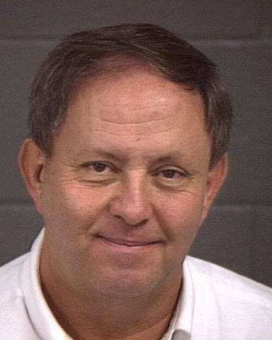

Message from Sheriff Lynn Yeates

Welcome. After 33 years working for the Sheriff’s Office, I was elected and took office in January 2007. In November 2010, I was re-elected for another four year term. I appreciate the opportunity the citizens have given me to serve them and it has been a pleasure to do so. The purpose of this annual report is to explain to the citizens what changes have been made during the last year, provide crime statistics and explain the efforts on our part to serve the public.

My focus has been to create new or enhance existing partnerships with the citizens. Preparing this annual report is just one way of bettering the communication between the public and my office. I hope the information presented here answers questions and gives insight into our operations. After taking office, I informed my employees that nothing would be as important during my tenure as Sheriff as community relations. I truly believe this and continually reinforce this principle. For example, I instituted a program in which citizens that had contact with a deputy are surveyed on a random basis and asked about their encounter. This lets the citizens know I am truly concerned about their interaction with the department and lets the deputies know I am holding them accountable.

All of the department functions are explained in this report. As you will see, our department provides a variety of services. About half of our budget goes to corrections and a fourth to patrol. The majority of the budgets are spent on personnel.

The size and terrain of Box Elder County makes it a particularly unique and wonderful place to live. These same attributes, plus a growing population, create challenges for the Sheriff’s Office. It will take great efforts by the Sheriff’s Office to keep pace with the changing nature of our county. It will be impossible to accomplish without a cooperative effort with our citizens.

Box Elder County Population 2013 | 50,290
BESO Sworn Officers | 28
Administration, Patrol, Investigations
# of Officers per 1000 population | 1.85

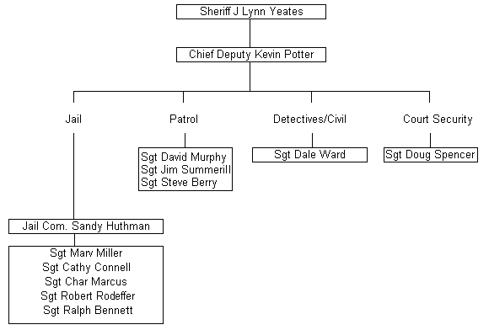

Mission Statement
-Reduce crime and the fear of crime.
-Establish a solid partnership with the citizenry to create safe and secure communities.
-Provide a knowledgeable staff that ensures professional commitment to law enforcement, is focused and dedicated to the citizens and communities and uses imagination, innovation and resourcefulness.
-Provide high quality, cost effective, accountable services.
-Standards for law enforcement must include Fair Access, Public Trust, Safety and Security,
-Coordinated Team Work with officers and citizens and Community Involvement/Responsibility.

Department Patch

Green and Tan colors- represent Sheriff’s Colors and mountain and desert surroundings.
1856- Year the Box Elder Sheriff’s Department was established.
Trains/Spike- Transcontinental railroad completed in our county

Marshland- Migratory Bird Refuge
Mountains- Represent the various mountain ranges in our county, some of which are almost 10,000 ft.
History, Agriculture and Industry- Three things that make Box Elder County famous and a great place to live in.

Uniforms
While the department colors haven’t changed, new hats, jackets, pants and other items have been approved.

Vehicles
We have a fleet management program whereby all deputies will have 4 wheel drive vehicles. The size and terrain of our County require 4 wheel drive in many cases. In the past, deputies would have to switch vehicles to respond to calls in certain areas. We felt valuable time was wasted during this switch.

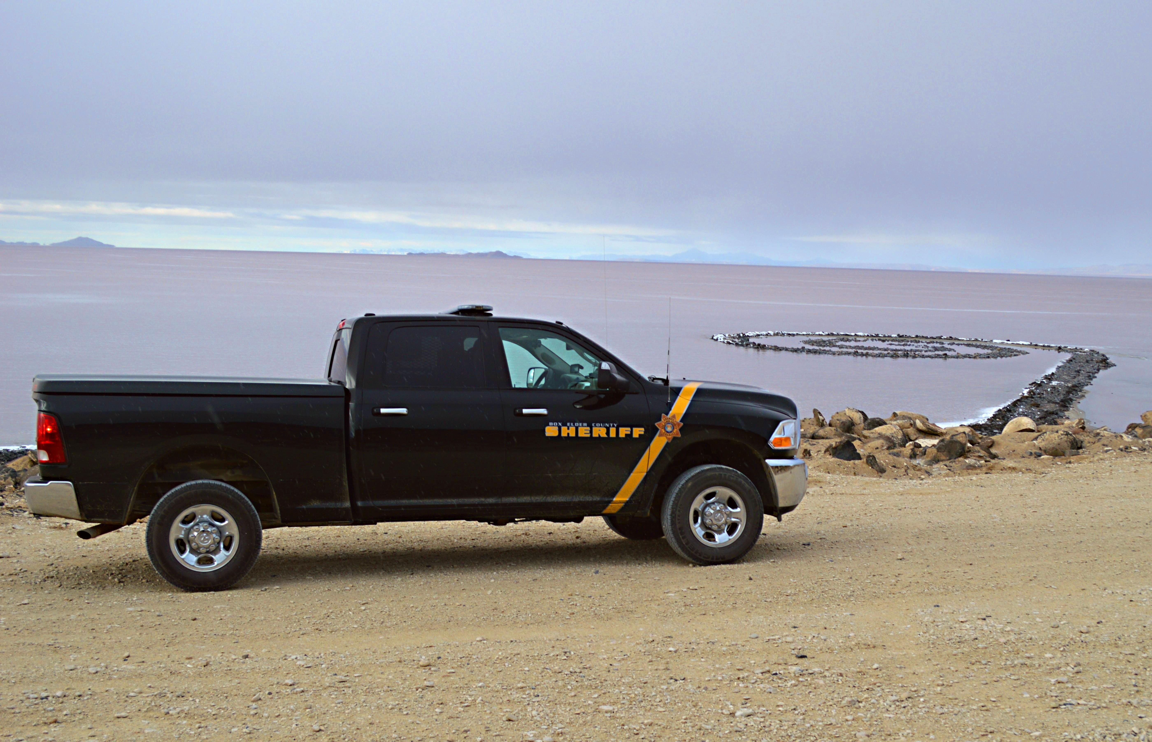

Budget
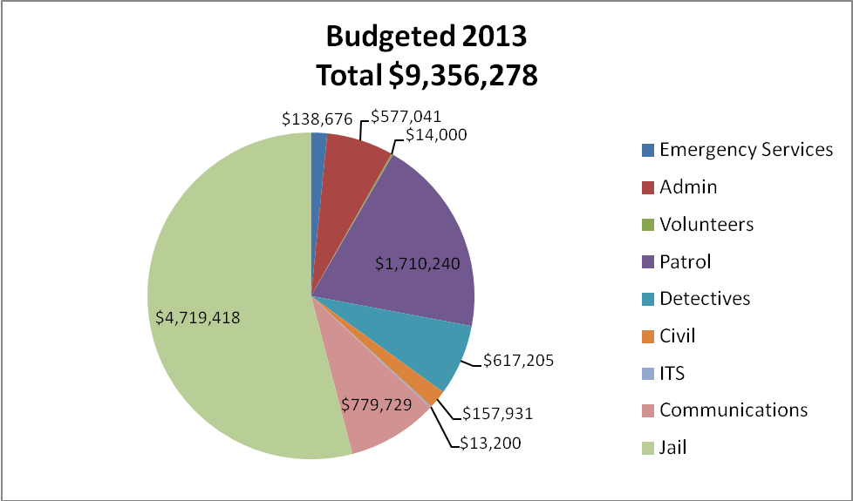
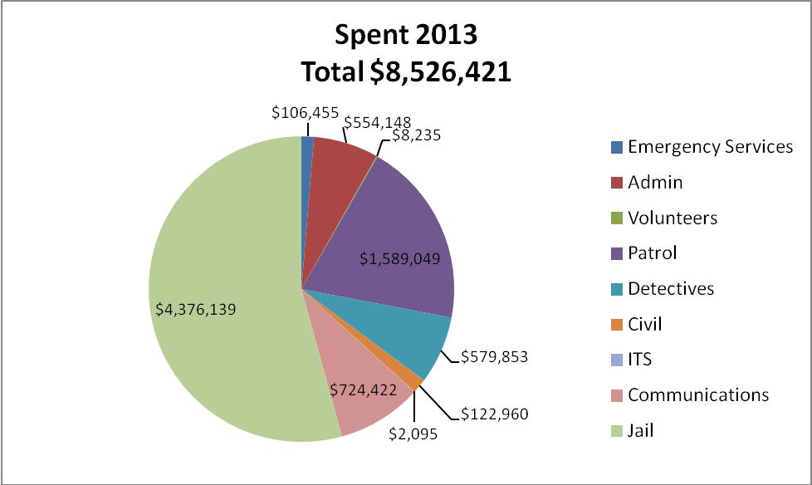

Detective Division 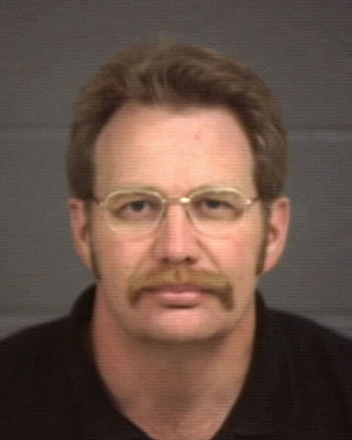
The detectives are supervised by Sgt. Dale Ward. Sgt Ward is also the field supervisor for the Narcotic Task Force as well as the Sheriff’s Civil division.

The detective division investigates major crimes committed in the county. There are four detectives, one of whom is assigned full time to the multi-jurisdictional narcotic task force. The other three detectives specialize in property crimes, sex crime management, fraud, and crime scenes. They also manage the evidence room.



Box Elder County Multi-Jurisdictional Narcotic Task Force (Strike Force)

The Sheriff’s Department participates in the Strike Force by assigning one full-time detective and a part-time field supervisor. Brigham Police also provides a full-time detective and part-time administrator. Tremonton Police provides a full-time detective.
The Strike Force was set up to allow targeted, focused investigation on drug use and traffic in Box Elder County. The Strike Force operates with the assistance of federal grants. The Strike Force also gives presentations to work, social, school, and civic groups. If you would like a presentation, please call the Strike Force secretary at (435)734-6490

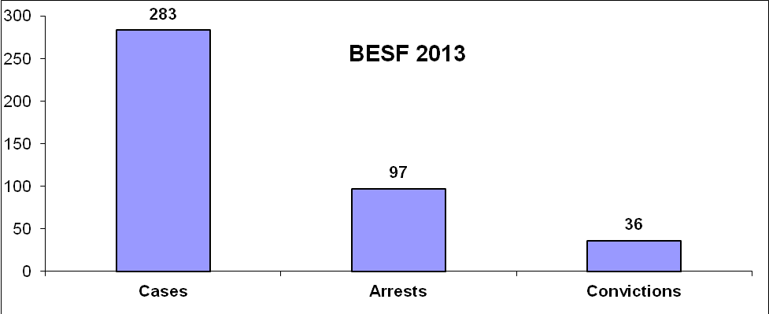

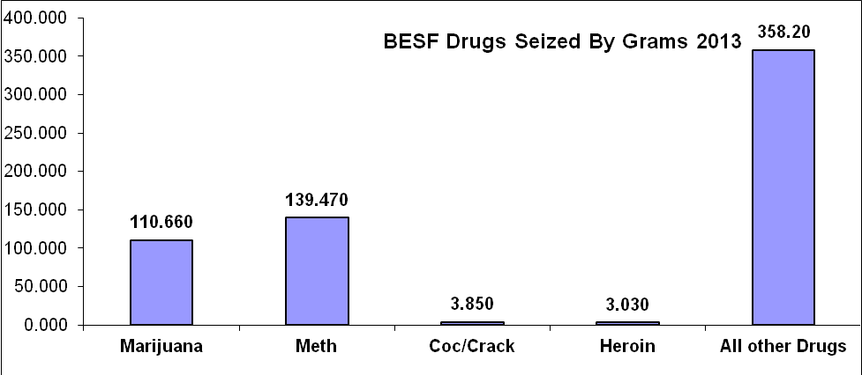
*Also seized were 1951.5 Rx Pills Valued at about $39,030.

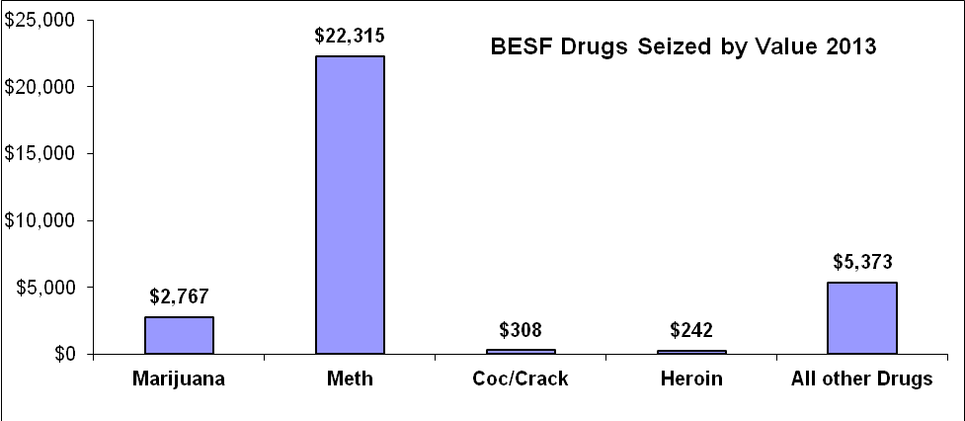

Civil Division

The Sheriff is designated by law to serve civil processes and execute court orders. There is a full-time deputy and full-time secretary assigned to this division. Often, the Patrol or Detective Division will assist in civil process serving to meet demand.

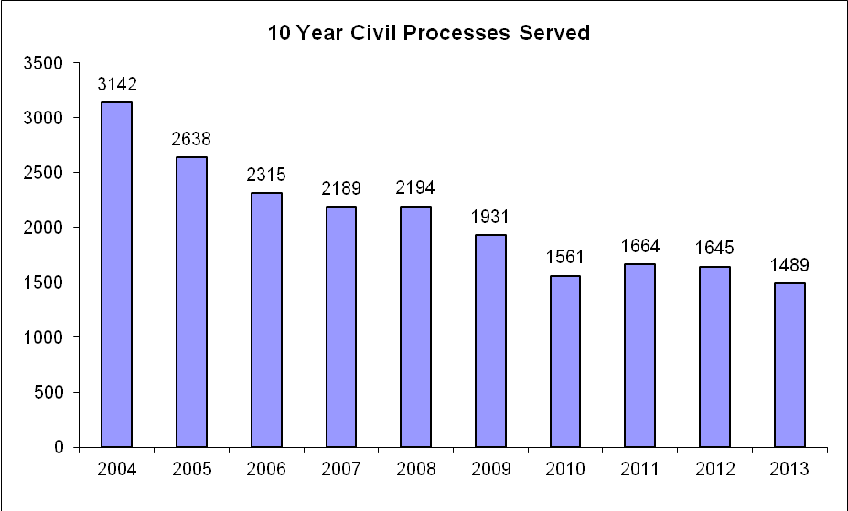

Court Division 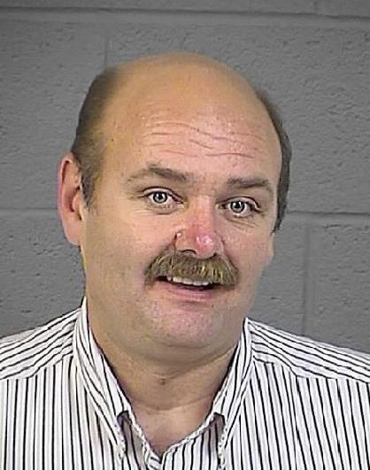

This division is supervised by Sgt. Doug Spencer.

The Sheriff is required, by law, to provide services to the District Court, Juvenile Court and the new Box Elder Justice Court building. This includes Bailiff duties and building security.

A Bailiff of the court is tasked with the safety of the judge and court staff and to maintain order in the courtroom.

The Security aspect includes monitoring court buildings and areas through a control center, magnetometers, security entry points and uniformed officers.

District Court Bailiff Hours: 1,812

Justice Court Bailiff Hours: 1,533.5

Total Hours 3,345.5

District Court Security Hours: 6696

13,879 visitors to the 1st District Court House in 2013.
11,268 Visitors to the Justice Court in 2013

Patrol Division 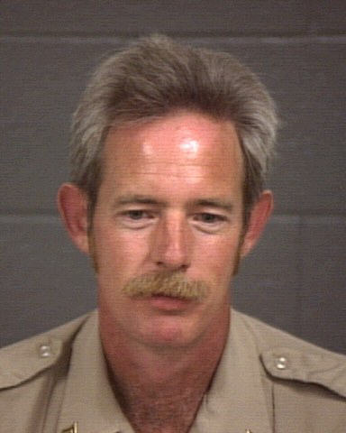 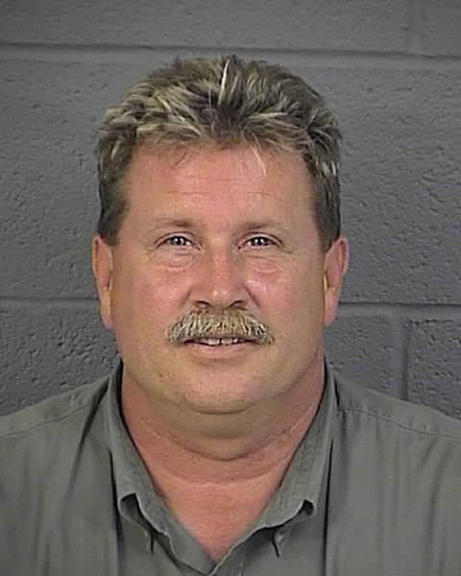 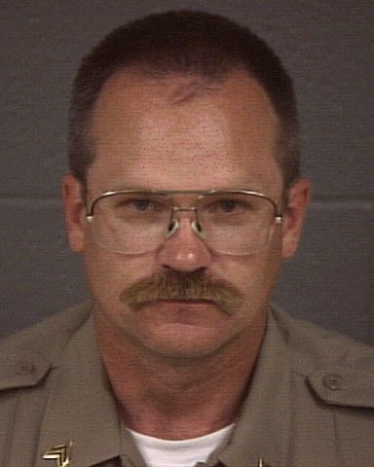
Murphy Berry Summerill

The patrol division is supervised by Sgt. Dave Murphy, Sgt. Steve Berry, and Sgt. James Summerill. There are 15 deputies and 3 Sergeants assigned to cover the county 24 hours a day. Due to the size of the county, deputies are assigned to cover patrol areas during their shifts. This includes the western part of the county.

Community Area Representatives –CAR
In additional to regular patrol duties, deputies are assigned a town or area in the county. They are expected to attend community meetings or functions and have an expertise in that community. To find out what deputy is assigned to your area, please call one of the patrol Sgts. (Sgt. David Murphy 435-734-3826, or Sgt. Steve Berry 734-3885 or Sgt. Jim Summerill 734-3806).

K-9
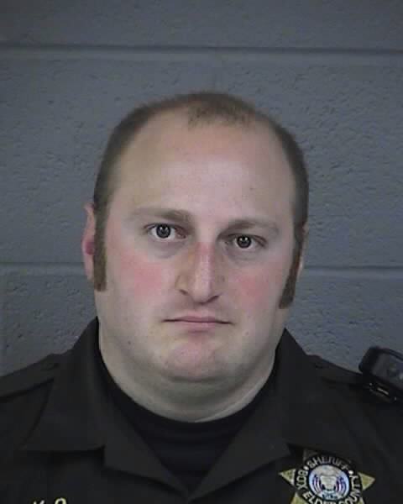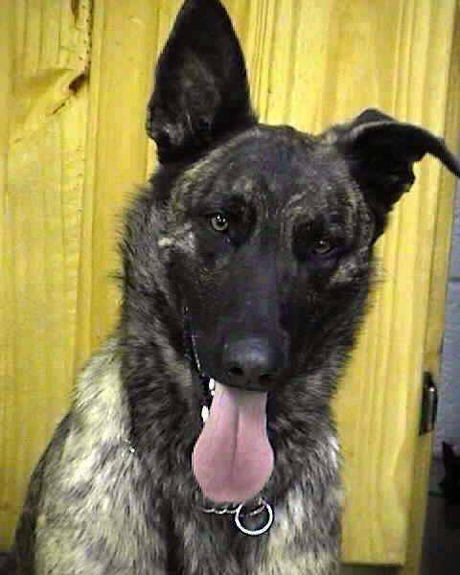
Deputy Ted Bennett was picked as a new K9 handler in 2011. He is working with K-9 Guri, a Dutch/German Shepherd. They graduated from a 3 month K-9 training and certification at the Police Academy in January 2012.

SWAT/SOG/Negotiations

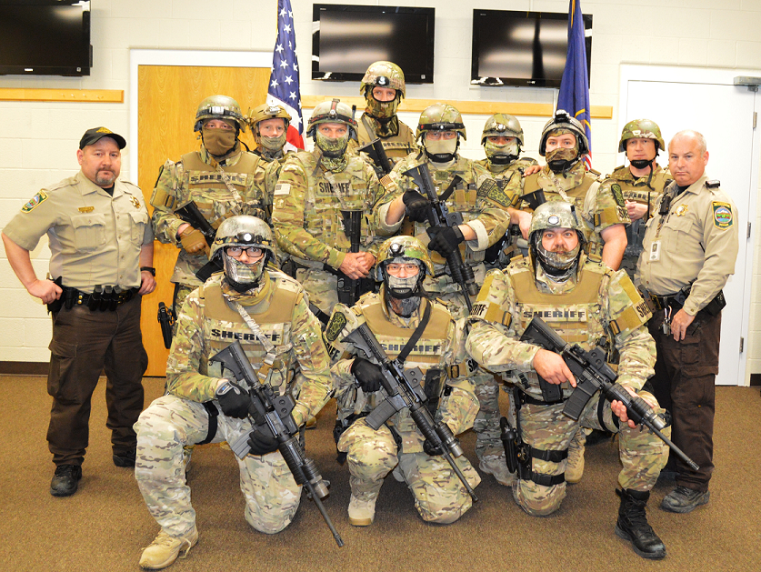

BESO started up a new county team comprised of BESO officers and will respond to SWAT/SOG calls in the areas patrolled by BESO and other areas upon request.
Our Crisis Negotiations Team is comprised of 4 officers who are certified or are currently attending a certification in negotiations and are separate from the SWAT/SOG Team.

Drug Recognition Experts (DRE)
The county has Officers certified as DRE. The Officers are trained to recognize the physical, clinical and neurological signs and symptoms associated with different kinds of drug use. DRE’s are an invaluable asset for drug related DUI’s and other crimes.

2013 Calls for Service by Nature
911 Unknown | 57 |  | Juvenile Prob | 49 |  | Stab/Gunshot | 4
Abandoned Vehic | 25 |  | K9 | 24 |  | Stalking | 1
Agency Assist | 482 |  | Keep The Peace | 6 |  | Suicide Attempt/Threat | 26
Aircraft | 1 |  | Littering | 6 |  | Suspicious | 243
Alarm | 90 |  | Lost Property | 17 |  | SWAT | 1
Alcohol Offense | 16 |  | Medical | 182 |  | Tazer Deploy | 1
Animal Problem | 267 |  | Mental Problem | 2 |  | Tel Harassment | 14
Asslt by Prsnr | 2 |  | Missing Person | 11 |  | Theft | 100
Attempt Locate | 4 |  | Motorist Assist | 33 |  | Theft Auto Motive | 8
Bad Check | 4 |  | Noise Complaint | 26 |  | Threatening | 26
Burglary | 44 |  | Offender Search | 6 |  | Tip | 15
Child Abuse | 25 |  | Overdose | 8 |  | Tobacco Violation | 2
Citizen Assist | 436 |  | Paper Process | 11 |  | Traffic Enforcement | 3
Com Policing | 362 |  | Parking Problem | 10 |  | Traffic Hazard | 52
CRIM MISCHIEF | 2 |  | PD Accident | 74 |  | Traffic Offense | 22
Custodial INT | 15 |  | PI Accident | 32 |  | Traffic Problem | 1
Death Invest | 5 |  | Pornography | 1 |  | Traffic Stop | 25
Disorderly | 9 |  | Private Tow | 1 |  | Transport Juven | 44
Drug Rec Expt | 10 |  | Probation Viol | 1 |  | Transport Pris | 123
Drugs | 30 |  | Property Damage | 53 |  | Trespassing | 45
DUI | 11 |  | Prot Order Viol | 11 |  | Truancy | 1
False Report | 1 |  | Prowler | 5 |  | Unknown Problem | 9
Family Fight | 58 |  | Psychiatric | 4 |  | Unknown Trouble | 1
Fatal Accident | 1 |  | Reckless Drivin | 7 |  | Unsecure Premis | 41
Fire | 97 |  | Recovered Vehicle | 3 |  | Utility Problem | 2
Fix It Ticket | 11 |  | Road Debris | 2 |  | Vagrancy | 1
Follow Up Inv | 7 |  | Robbery | 1 |  | Vandalism | 29
Found Property | 24 |  | Safety Hazard | 5 |  | Vehicle Burg | 13
Fraud | 42 |  | School Safety | 211 |  | Vehicle Lockout | 6
Gas Skip | 14 |  | Search & Rescue | 8 |  | VIN Inspection | 214
Gas Spill | 4 |  | Security Check | 6 |  | Wanted Person | 84
Harassment | 18 |  | Sex Offense | 25 |  | Weapon Offense | 51
Health & Safety | 7 |  | Sheriff Service | 6 |  | Welfare Check | 48
Impound | 13 |  | Shoplifter | 1 |  | Wildlife | 15
Indecent Expos | 1 |  | Simple Assault | 22
Intoxication | 7 |  | Slide Off | 7 |  | TOTAL | 4350
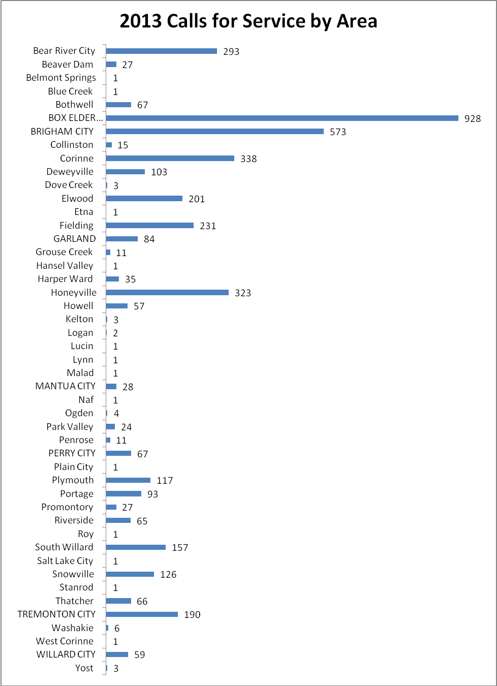
Total 4350

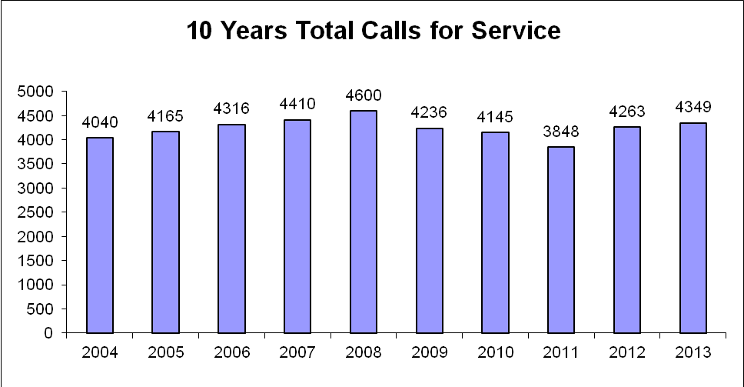

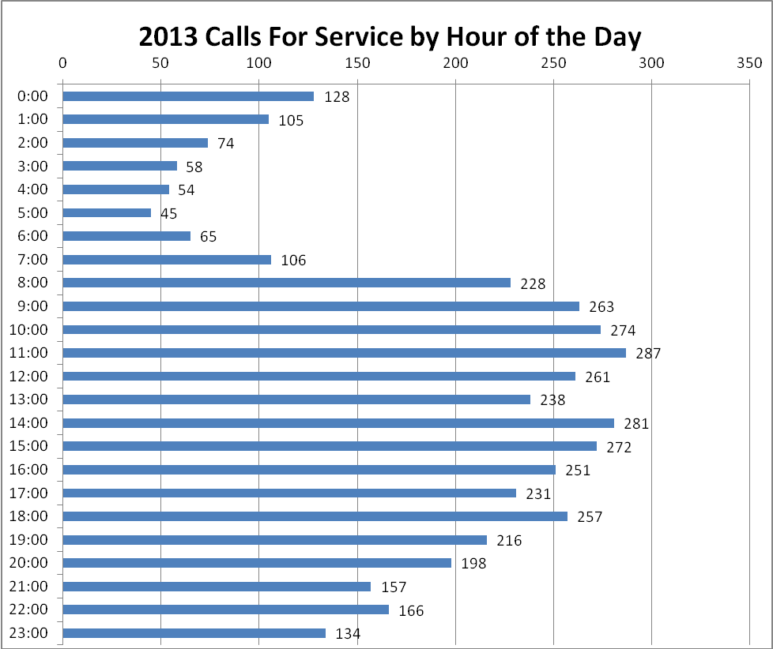

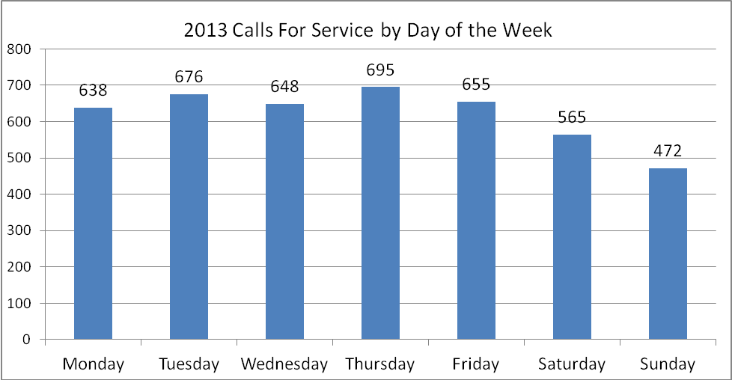

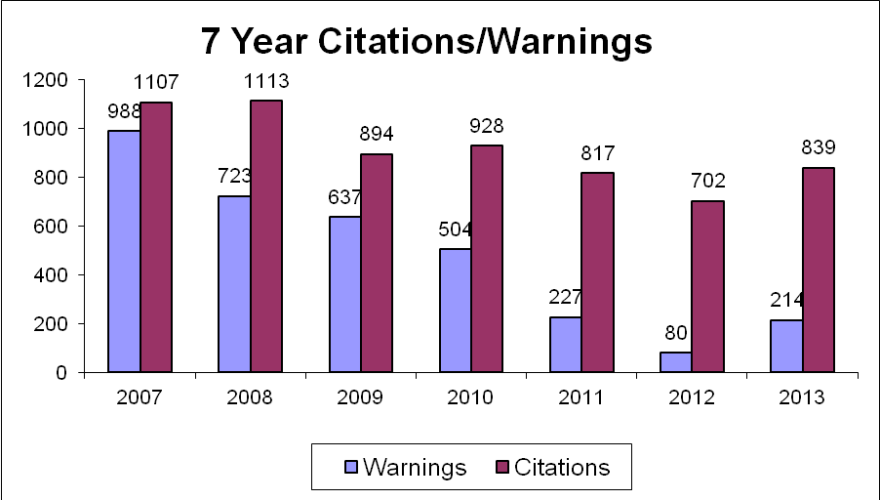

*854 Verbal warnings for traffic violations were also given in 2013.

Speed-Box

At the end of 2009 the Department purchased a device that measures traffic at specific locations. The Speed-Box, as we like to call it, can be placed at any location in the County to measure 4 traffic statistics; how many vehicles passed by, time of day, speed, and direction of travel. From this data we see the true picture of each location’s traffic. This data helps Deputies know how best to conduct speed enforcement.

Corrections Division 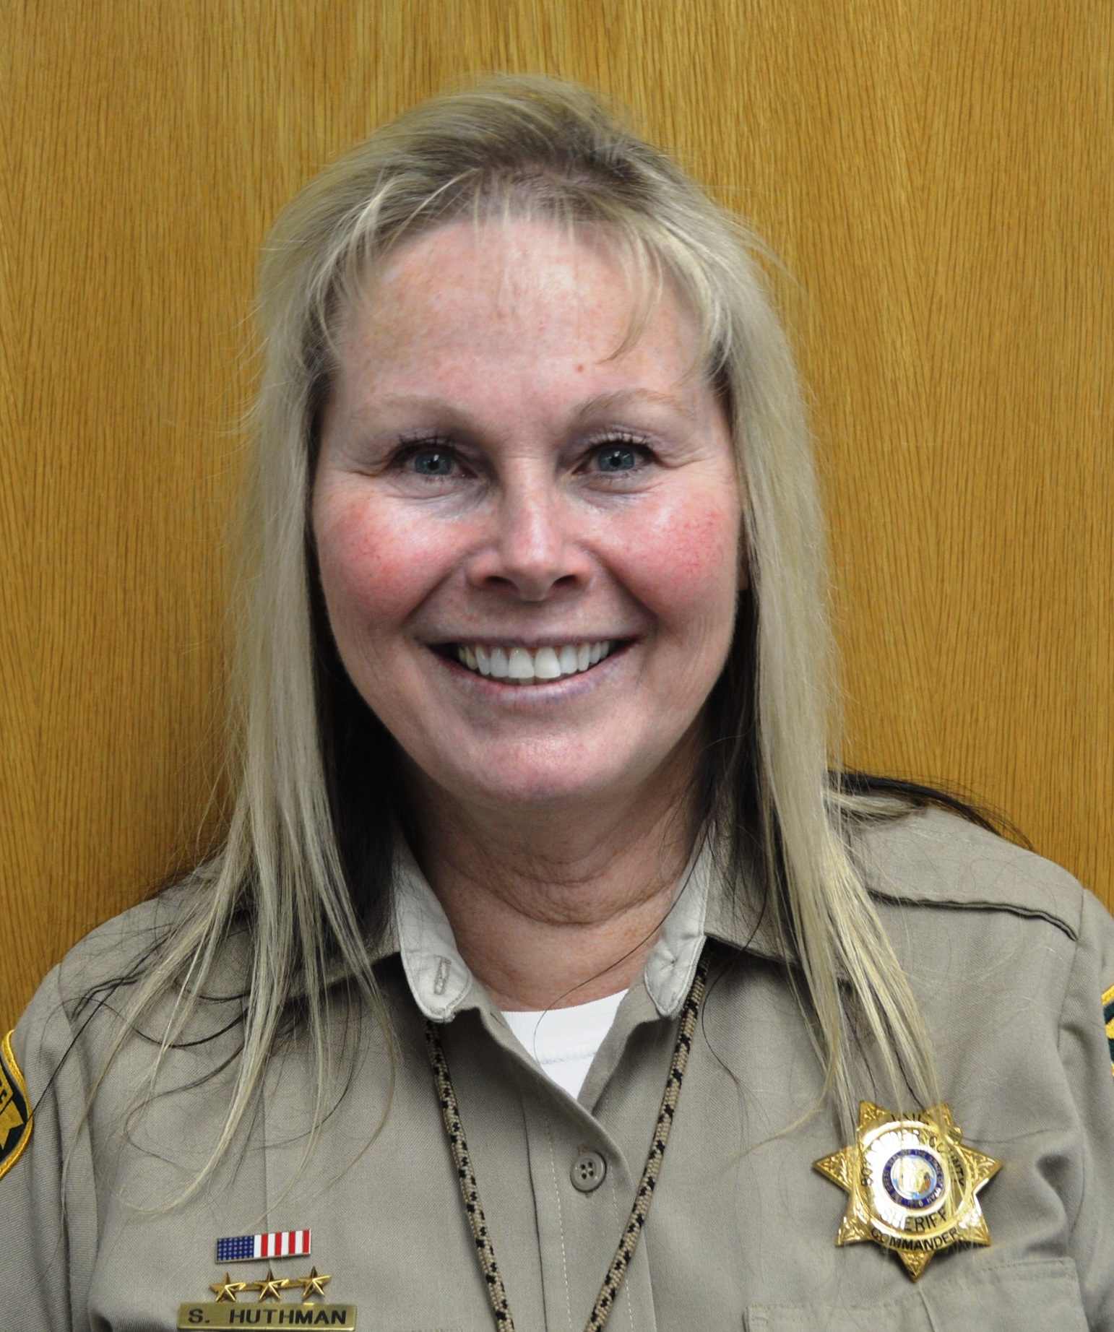

The Corrections division is supervised by Commander Sandy Huthman.
The following is a summary of the year 2013 for the Box Elder County Jail. The Jail consists of several individual divisions providing different services. This includes Corrections Operations, Inmate Services, Visitation, Maintenance, Medical, Transportation, Court Security, Kitchen and SRT(Special Response Team). The following report is a summary of each.
Corrections Staff:
1-Jail Commander
1-Assistant Jail Commander/Sgt
4-Sgts
20-Officers
1-Visitation Officer
1-Work Crew Officer
4-Inmate Services Officers
2-Transportation Officers
6-Court Security Officers
Civilian Staff:
1-Maintenance Person
2-Nurses (1-Full time and 1-Part time)
1-MD
5-Kitchen Staff
Volunteer Services:
AA
Assembly of God
Bible Study
Catholic Church Services
GED
LDS Church Services
LDS Indexing
Mennonite Services
Non-Denominational Church Services
Parenting
Relief Society
Corrections Operations:
We had our jail inspection in July for both the Sheriff’s Association and the State Department of Corrections. We are 100% compliant with the current jail standards.
In 2013 the jail training hours totaled 3681.75. This is attained through outside agencies and in-house training put on by Corrections staff. It encourages all Officers to submit ideas and suggestions for improvement of processes within the jail. This also enhances the safety of the Officers, Civilians and the Inmates, and the security of the jail and the overall knowledge that each Officer develops throughout their career. It is my goal to find any training or tools that would make the jail more productive and as liability free as possible.
Inmate Services
Work Crew:
We have 1 Inmate Work Crew with 1-Officer and minimum of 2 inmates.
Our Work Crew grew all the flowers for the Sheriff’s office. This year they also grew hanging flower pots. The garden was very profitable producing approximately 4500 lbs of vegetables(potatoes, carrots, tomatoes squashes, etc). This is an invaluable resource for the jail, and learning experience for the inmates.
Work Crew County hours:
Fair Time: 224 hrs
Fairgrounds: 476 hrs
Voting Booths: 60 hrs
Road Shed: 56 hrs
Misc County: 1064 hrs (This is greenhouse, mowing, snow removal, garden, and jail maintenance)
Savings to the County: 1,880 hrs @ $10.00 per hr =$18,800.
Visitation:
2011: 3244 visits, 12 average per day
2012: 4129 visits, 16 average per day
2013: 3978 visits, 15 average per day
*Visitation is open Tues-Sat 10-5 pm
Maintenance:
Maintenance has been very busy this year replacing worn out items/equipment in the jail. One of the boilers was replaced, and replaced parts on roof top units. New cameras in 3 areas which allows for better observation of the inmates and better safety and security of the jail.
Medical:
We continue to pay Medicaid amounts for our inmate medical bills. We do bill the amount we pay on the medical to the inmate. A rough estimate on the overall payment of a medical bill is about 25% of normal costs.
Court Security:
Sgt Spencer was over at the courts.
Scanned through security-25,147 people
Justice Bailiff-1,533.55 hours
District Security-6,696 hours (Reimbursed from the state at 3,402 @ $25.00 per hour and 3,294 hrs @ 25.25= $168,223.50)
District Bailiff-1,812 hours (Reimbursed from the state at 948 @ $25.00 per hour and 864 @ $25.25= $45,516.00)
Total State reimbursement for Security- $212,147.08
Kitchen:
The kitchen still receives excellent inspections from the health department due to the tremendous job that the kitchen staff does ensuring that the sanitary condition of the kitchen is maintained. There were 154,271 meals served by the kitchen this year. The average cost per meal was $2.16.
SRT (Special Response Team, This is the Jails equivalent to SWAT):
We have 15 members on the SRT team. They train the second Tues of every month here at the Sheriff’s Office. The Officers have been instructed to call out SRT rather than handling any inmate that is uncontrollable to prevent any injuries to the Officers and/or the Inmates. SRT is specifically trained to manage these types of situations.
There were 5 SRT callouts for 2013 with 0 injuries.
Areas of income:
State Inmate Housing:
2011 Total Inmates-360 Total Inmate Days-9561 / Amount Received- $430,245.00 (@45.00 per day per inmate)
2012 Total Inmates-327 Total Inmate Days-8761 / Amount Received- $394,245.00 (@45.00 per day per inmate)
2013 Total Inmates-355 Total Inmate Days-9714 / Amount Received- $437,130.00 (@45.00 per day per inmate)
Condition of Probation and Parole:
2012 State Fiscal Year (7/1/11-6/30/12) Total Inmate Days-4967 / Amount received- $228,898.00 (This actually works out to approximately $46.00 per day. We do bill at 27.10 per day but received an allotted amount determined by State appropriation).
2013 State Fiscal Year (7/1/12-6/30/13) Total Inmate Days-7,098 / Amount received- $227,702.00 (This actually works out to approximately $32.08 per day. We do bill at 27.10 per day but received an allotted amount determined by State appropriation).
Work Release:
2011 57-Work Release Inmates / Amount Received- $13,473.33
2012 31-Work Release Inmates / Amount Received- $8,769.38
2013 77-Work Release Inmates / Amount Received-$17,549.00
Pay for Stay:
2011- $18,176.57
2012- $13,244.00
2013-$11,310.19 The decrease in the amount collected was due to taking inmate funds for their medical expenses that were owed before “Pay for Stay” expenses.
Day Reporting:
2011- $795.00
2012- $485.00
2013- $232.00
Commissary:
We are using the Spillman system to manage Inmate funds and commissary.
Total Sales- 2012: $81,535.98
2013: $99,455.36
Phones:
We have basically stayed with the same phone company since the beginning of the operation of the jail. It started out as Gateway, then FSH and now they are currently called GTL. They have many features that are available to every officer at the Sheriff’s Office. One advantage of remaining with this company is that we can go back indefinitely and get recordings of calls made from the inmates.
GTL Phone income for 2012- $30,187.93
2013- $37,950.92
Total of all monies brought in by the jail and turned into the county for 2012: $757,365.29 2013: $831,329.47
Housing Costs:
2011-Calendar Year Activity: $3,399,509.59 Total Inmate Days: 45,479 Cost per day: $74.74
With Court Security/Transport-Calendar Year Activity: $576,515.96 Cost per day: $87.42
2012-Calendar Year Activity: $3,368,386.87 Total Inmate Days: 41,899 Cost per day:$80.39
With court security/Transport-Calendar Year Activity: $678,473.33 Cost per day: $96.58
*2013- Activity: $3,670,794.41 Total Inmate Days: 50,165 Cost per day: $73.17
With court security/Transport-Calendar Year Activity: $4,376,138.84 Cost per day:$87.23
*Inmate housing cost is determined by the number of inmate days divided into the cost of operating the jail for the year. (ex. The higher the inmate count the lower the cost per day)

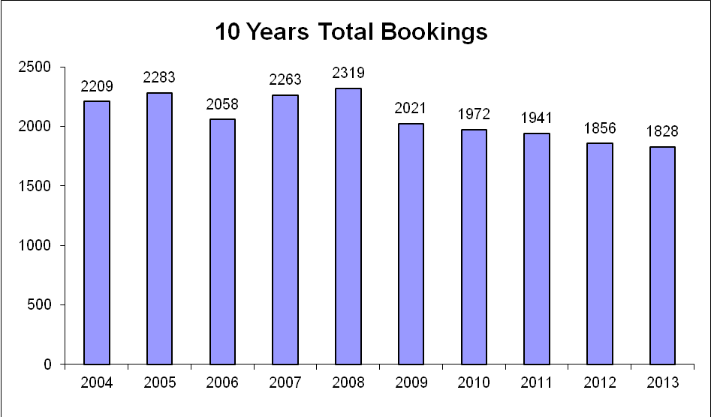

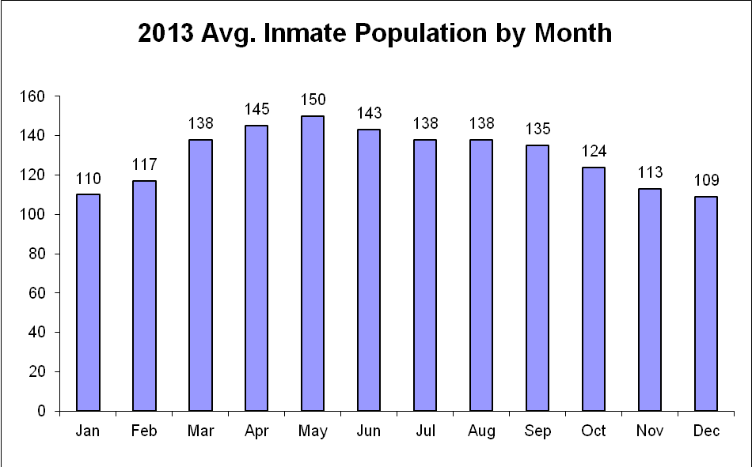

Emergency Management
Emergency Management is the process of mitigating, planning, responding and recovering from natural disasters/terrorism/haz-mat. The Chief Deputy and the Sheriff have this assignment.
Emergency Medical Services falls under the Sheriff who oversees 12 Emergency Medical technicians and 2 ambulances in Park Valley.

Buildings and Grounds
A full-time civilian employee is responsible for the care, repair, maintenance and upkeep at the jail, offices, Sheriff’s desert cabins and storage buildings.

Volunteer Organizations

Box Elder Sheriff Search and Rescue
With about 30 active members, this all volunteer group will leave their “real” jobs at a moment’s notice to conduct rescue or recovery operations. They are equipped with 4 wheel drive trucks, ATV’s, UTV’s, snowmobiles, snow-cat, light plant truck and a command center. They conduct approximately twenty operations per year. They also provide security at the County Fair.

Box Elder Sheriff Scuba Team
This all volunteer group specializes in water rescue and recovery. 20 members are certified rescue divers and 20 are support staff. They are equipped with a pontoon boat, zodiac, 2 airboats and a command center. They assist at the County Fair and operate on funds raised by selling the famous “Scuba Burger” at Peach Days.

Box Elder Sheriff’s Horse Posse
The volunteer group dazzles crowds at the County Fair with a horsemanship display.

